**Problem Set 2**

This problem set covers material from OIS Chapter 2 Section 2.2 to Chapter 3 Section 3.1. It makes use of similar data to that we discussed in class. Partial credit may be given for answers that are correct in part, but not in full.

**Part I: The 2015 UK Election (32 points)**

Like the 2019 UK Election, the 2015 UK Election saw the Conservatives (aka the Tories) win a majority in Parliament. This section makes use of data from that election. (Note: Con=Conservatives, Green=Green, Lab=Labour, LD=Liberal Democrats, SNP= Scottish National Party).

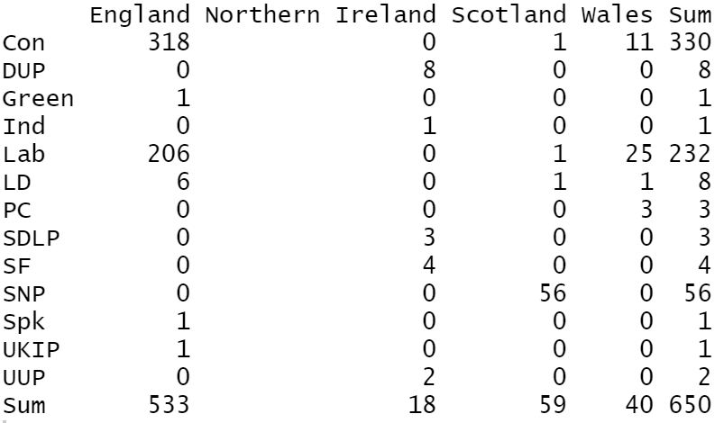

1. Below is a contingency table showing the number of seats won by each party by country. (16 points)
   1. Please calculate the row proportions for Labour for each country. You may use a calculator to divide large numbers, but please show how you get the numbers (8 pts.)
   2. Please calculate the column proportions for Scotland for each party. The above rules about calculators apply. (8 pts.)
2. Before the 2015 UK Election, the pollster [YouGov](https://yougov.co.uk/topics/politics/articles-reports/2015/06/08/general-election-2015-how-britain-really-voted) asked a question about which newspapers people read, as well as their preferred party in that election . I would like you to think about what the reader takes away from this visualization and also think about the results. (20 pts.)

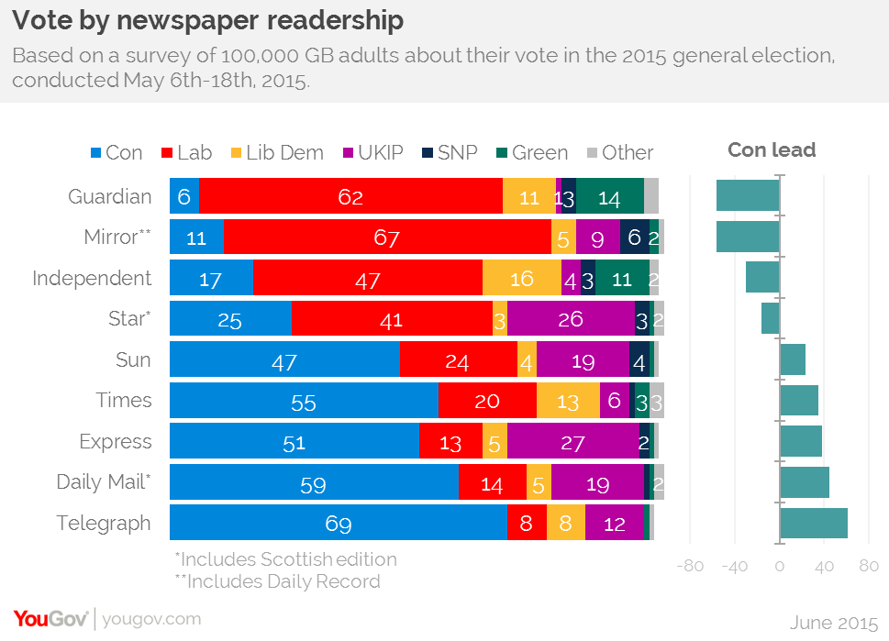

* 1. What is a benefit of using a stacked bar plot with percentages? What information does this visualization not give you that you would have with frequencies? (4 pts.)
  2. Which publication has the highest percentage of Conservative readers? Which has the smallest percentage? Are there any publications where Conservatives aren’t in the top two parties for readership? (i.e., third or below) If so, which ones (s). (6 pts.)
  3. Would you want to display this information in a pie chart? Why or why not? (4 pts.)
  4. Let’s say you selected two *Telegraph* readers at random. What is the probability that both would be Conservatives? What is the probability that neither would be Conservatives? (6 pts.)

**Part II: The 2020 US Election in Texas**

1. Below is a election results map from the [New York Times](https://www.nytimes.com/interactive/2020/11/03/us/elections/results-president.html?action=click&pgtype=Article&state=default&module=styln-elections-2020&region=TOP_BANNER&context=election_recirc) that shows whether Joe Biden or Donald Trump won a Texas county in the 2020 election. If a county is shaded lightly, that means that it was a close result, while a more shaded in county indicates a wider victory. Blue indicates a Biden win, while red signifies a Trump win. Large cities are labelled on the map. (6 pts.)

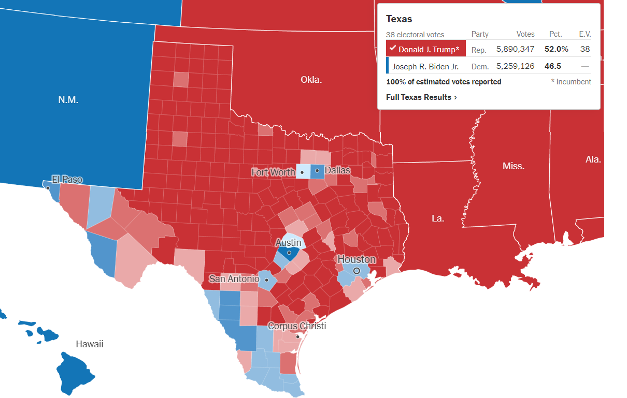

What part (s) of Texas did Joe Biden perform most strongly? Which part of Texas saw Trump do the best? Do any regions seem particularly competitive for both candidates (i.e., lots of close wins?) (6 pts.)

1. The below map shows *the shift* in vote in Texas from 2016 to 2020. Counties with blue arrows saw Joe Biden do better than Hillary Clinton did in 2016, while red arrow represent counties where Trump did better in 2020 than he had in 2016. (6 pts.)

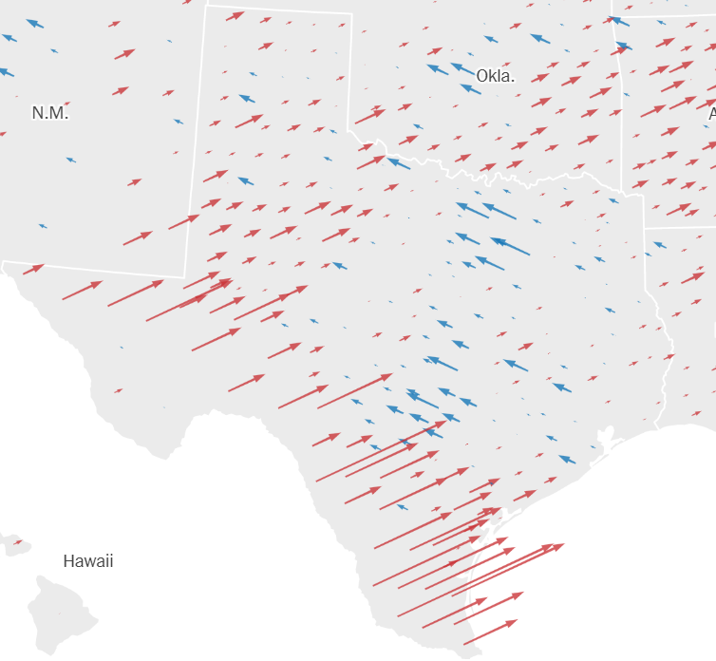

What parts of Texas saw the biggest swings towards Biden? Which areas saw the biggest swings towards Trump? (Hint: use the map above for city labels). If a county sees a big swing towards a candidate, does it necessarily mean that candidate has won that county? (6 pts.)

**Part II: Probability and the 2018 Washington 8th Congressional District Election (32 pts.)**

One of the final polls conducted by Siena College for *the Upshot* was in Washington’s 8th Congressional District. This [poll](https://www.nytimes.com/interactive/2018/upshot/elections-poll-wa08-3.html) had Democrat Kim Schrier ahead of Republican Dino Rossi by a 48-45% margin. On [Election Day](https://ballotpedia.org/Georgia%27s_6th_Congressional_District), Schrier defeated Rossi by about five percentage points, 52.4% to 47.6%. This section’s questions focus on that poll and the election results in this district.

1. This chart shows how the result in the poll changed as more people were polled. This question focuses on this chart. (6 pts.)

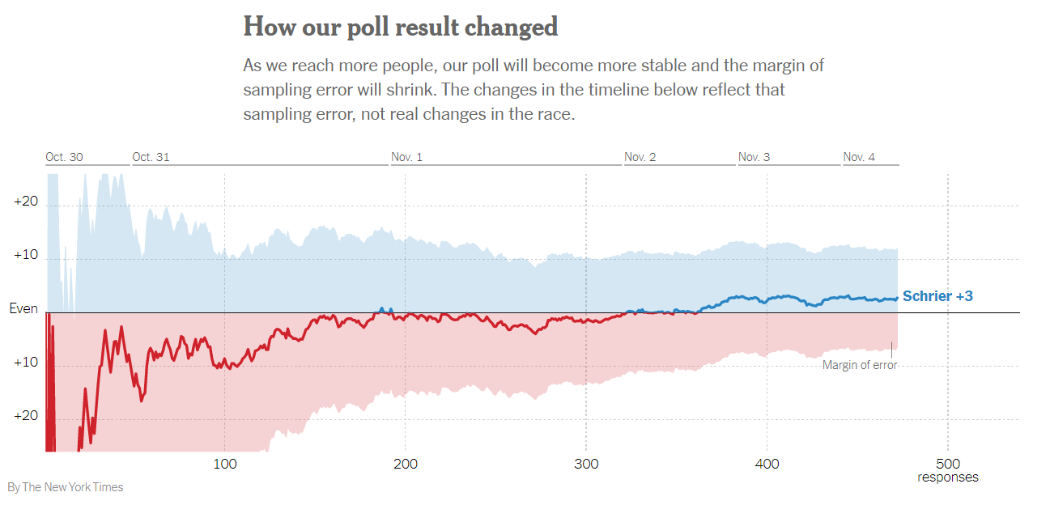

* 1. Why does Schrier’s lead in the poll stabilize close to her actual margin on Election Day as the number of poll respondents goes up? What principle does this illustrate? (4 pts.)
  2. Let’s say we were to add an additional 500 respondents to this poll. Would we expect the margin to stabilize or begin to oscillate more? Why? (2 pts.)

1. Now please consider the actual results on Election Day (Schrier 52.4%, Rossi 47.6%) when calculating these probabilities. (26 pts.)
   1. What is the probability that a randomly selected voter is either a Schrier voter or a Rossi voter? Please show your work. (4 pts.)
   2. What is the probability that a randomly selected voter is a Schrier voter and a Rossi voter? Why is this the case? (4 pts.)
   3. Let’s say that you randomly selected 2 voters at random. What it is probability that they both would be Schrier supporters? What is the probability that they both would be Rossi supporters? Please show your work. (8 pts.)
   4. If you randomly selected 5 voters and all of them were Rossi voters, are you “due” for a Schrier supporter on your 6th draw? Thinking just about that draw, what is the probability of selecting a Schrier supporter? (2 pts.)
   5. Washington is a notoriously rainy state. Yet in a 2018 poll, [73%](https://komonews.com/weather/scotts-weather-blog/poll-73-percent-of-northwesterners-like-the-weather-around-here) of people who live in Washington and Oregon like the weather in the Pacific Northwest. Assuming that this percentage holds in Washington’s 8th district and is independent from one’s political views, what is the probability that a randomly selected voter likes Northwestern weather and voted for Schrier? What is the probability that they do not like the weather and voted for Schrier? (8 pts.)

**Part III: Probability, the Partisan Affiliation of Governors, and the Winning Party in 2020 Presidential Election (20 pts.)**

This section makes use of data on the current partisan affiliation of US governors and the results of the 2020 presidential election at the state level. In 2020, Joe Biden and Donald Trump each won 25 states. Currently 27 states have Republican governor and 23 states have a Democratic attorney general. (In a few states, Attorneys general are appointed, but in most they are elected.)

1. Here, I would like you to consider the probability of various outcomes when it comes to the partisan affiliation of governors and a state’s vote in the 2020 presidential election. (20 pts.)
   1. The below probability distribution shows the four possible outcomes. Please fill in the two outcomes that are blank. Please show all of your work. (8 pts.)

|  |  |  |  |
| --- | --- | --- | --- |
| DPres, DGov | DPres, RGov | RPres, RGov | RPres, DGov |
|  | 12% | 42% |  |

* 1. Here I gave you the number of states that both presidential candidates won. Imagine that you only knew the total number of states and the number of states that Biden won. How could you find the percentage of states that Trump won? What does Bidenc represent here? (4 pts.)
  2. How many states have a governor from a different party than that of the candidate they voted for in 2020? Please show your work? (4 pts.)
  3. Looking at the above table, if you knew the party of the presidential candidate that won a state in 2020, would that help you guess the party of the state’s governor? Please explain your reasoning. Put differently, if I told you that Donald Trump won a state, what would be your guess for the party of the state’s governor? (4 pts.)